# JIRA Utility to Bulk Export Issues into Excel

JIRA has a maximum export limit of 1000 in a single export operation.

We don’t any straightforward solutions to export more than 1000 issues at once.

So we built a custom utility Jar solution, which would allow users to bulk export from JIRA irrespective of the number issues selected.

**Prerequisites**

Users should have JDK 1.8 installed in their System.

Please download it from here if you don't have it already : <https://www.oracle.com/java/technologies/javase/javase-jdk8-downloads.html>

# Working with the Bulk Export Utility

**1)** **Extract the zip file** into any convenient folder in your computer.

* You may use WinZip/ WinRar or similar tools for the Extraction.
* You would get a JAR file + LIB folder + Helper batch file.
* Ensure not to delete the LIB folder and to keep the JAR file and LIB folder together in one folder.



**2)** **Login to JIRA** **in any Web browser and** **Perform a JQL search** from

the **JIRA Search Issues Page**for the list of Issues you wish to Export**.**

You may also run a **Jira filter** which you have created earlier.

**3) Copy the complete URL** of the Search Issues Page or the filter results page:

* Eg URL 1 : <https://jira-qa.com/issues/?jql=issuetype%20%3D%20Test%20>
* Eg 2 : <https://jira-qa.com/issues/?filter=36024>

Please note that the Export Utility will NOT support inbuilt filters.   
These are filters with a negative Id "-" in URL. Eg : <https://jira-qa.com/issues/?filter=-1>

You can copy the JQL of the inbuilt filter and perform a fresh JQL search to make the URL compatible with the export Utility.

**4) Run the Bulk export Utility** by double clicking on the JAR file.

You would be presented with the below screen.

* In the URL field enter the JQL URL you have copied from JIRA
* Enter your JIRA credentials and click Login.

**If the Utility is NOT Working :**

* Try to run the '**Helper.bat**' file.
* If it’s still not running you might need to fix Java classpath in your System.

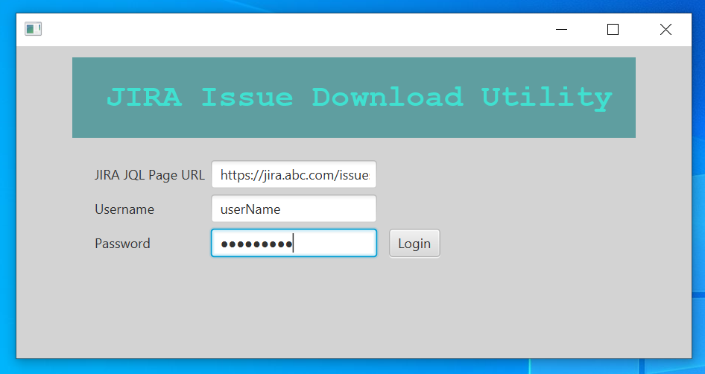

**5) In case of any Login error**,

* Notice the HTTP Error Code shown.
* Please verify your credentials and JIRA URL.
* Verify that you are not using any inbuilt filter (having negative filter id : filter=-1)
* Ensure the connectivity to JIRA instance from a Web browser.

**6) On Successful login** you would be greeted with the below screen.

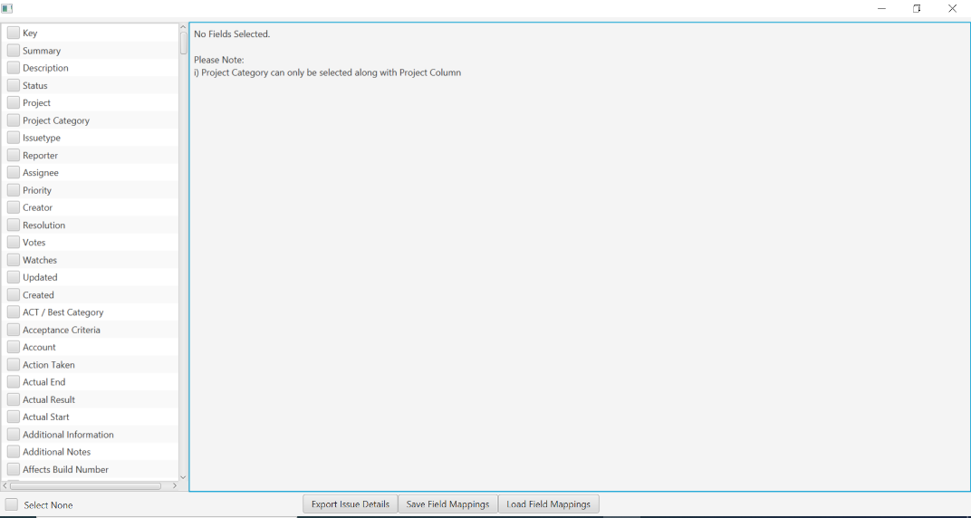

**7) Getting Familiar with the Use Interface**:

a) The Left Pane (1) shows the List of Custom Fields available for Selection.

b) The Center Pane (2) shows the List of Fields Selected by the User for Export.

c) Export Issues to Excel Button (3)

d) Save Field Mappings Button (4)

e) Load Field Mappings Button (5)

f) Message Box (6) displays Success or Error Messages.

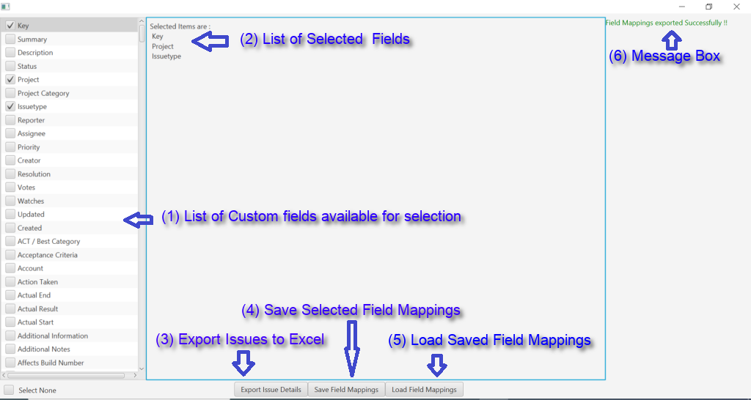

Please Note In order to Export 'Project Category' into the Excel File, you must select the 'Project' field as well.

**8) Performing an Excel Export :**

a. Select the required list of fields from the Left Pane marked (1).

b. The selected fields would be displayed in the center Pane marked (2).

c. Once the fields are selected, Click the '**Export to Excel**' button marked (3).

d. Select the Target directory to Save the Excel and Click Save.

e. The process make take few seconds to couple of minutes depending on the number of Issues to Export.

f. Wait for a Success OR Failure message in the Message Box (6).

e. Verify the Exported Excel File.

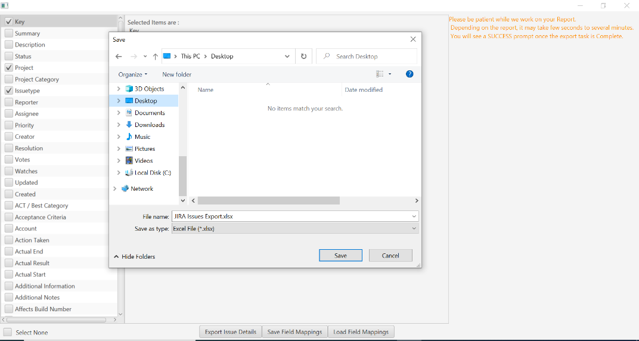

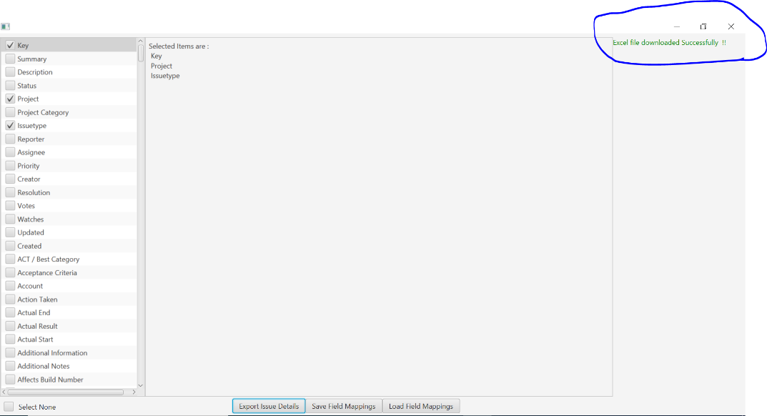

**9)** **Saving the Field Mappings**

Users can save their field selection preferences to their Local machine.

a. Select the required list of fields from the Left Pane.

b. The selected fields would be displayed in the center Pane.

c. Once the fields are selected, Click the '**Save Field Mappings**' button.

d. Select the Target directory to Save the Properties file and Click Save.

e. Verify the Success Message in the Message Box.

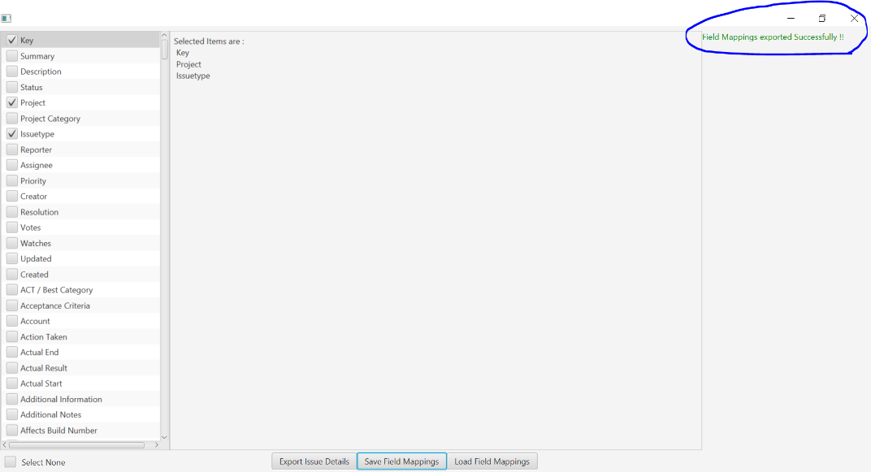

**10) Load Existing Field Mapping**

a) Click '**Load Field Mappings**' button.

b) In the File Browser window, navigate to the existing properties file and select it.

c) Verify the Success message and ensure that the desired fields are Selected.

d) Proceed with the Excel export for the selected fields.

